 Presentation

Pitch Deck

Project Name: Agric Market Match Platform

Bridge the information gap for farmers by:

Alerting them about real-time local market prices

Connecting them with nearby buyers or markets

By Felix Ineke/ Multiflexzy Tech

26/05/2025

01

### Write Your

#### Problem or Idea

### Farmer faces market prices on farm produce

### They can’t get current prices for produce to enable

### Sell at profits

### Market location and buyers are always issues

### Write Your Solution

### Real-time Price Alerts: SMS/email/web alerts for produce price changes

### Nearby Buyers/Markets Map: Locate potential buyers/markets using geolocation

### List Produce for Sale: Easily list available crops with quantity and preferred price

### For Buyers:

### Search & Filter Produce: Filter listings by type, location, and price

### Send Offers or Purchase Requests



06

# Product

Write what your product does here

*Match buyer and sellers with updates on market prices and location*

04

Target Market



100

Local and geographical markets



90 % of market men and women lack the price updates

### 

Millions of farm produce perish due to no buyers

14

# Market Size

100 markets

300o buyers

200 famers

100 produces

Yearly projects

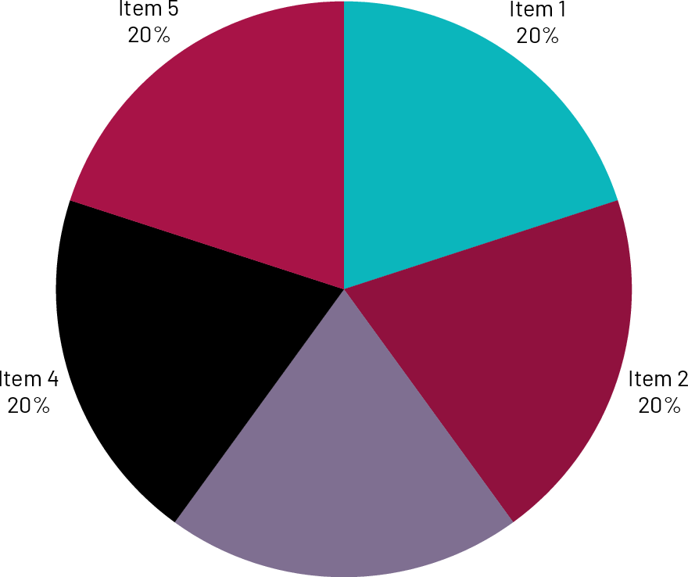

Item 3

20 %



Competitors

Shopping malls

Dealers

wholesalers

## Competitive Advantage

Use of app to bridge communication gaps between sellers and buyers

#### Project Traction

Tasks

information gathering



Design the app

Test run

Deploy





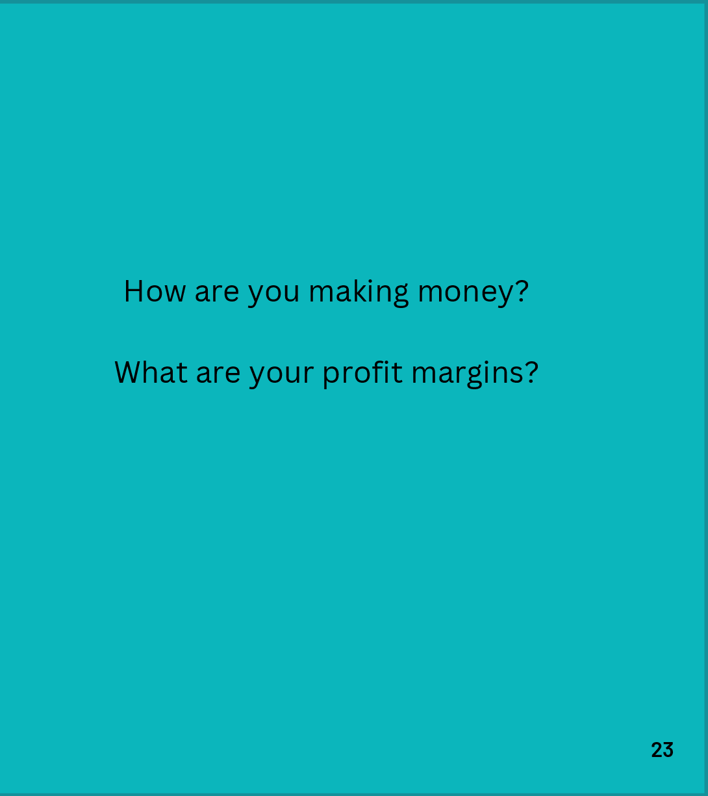Business Model



Go To Market

By advertising the app to them and the benefits

Social Impact

Bridge gaps between market people and facilitate communications

## Our Ask

* Startup capital of 50,000 usd
* To setup office and tools for administrations
* Hosting of a functional site for the app

#### Team Members

Add team members Names and tiles

Felix Ineke

CEO

Mike Onoja

Project Lead



e, @linkin/inekeche inekeonubifelix@gmial.com

17